Hands-on 5 - Implement Services for Managing Country

Name: Shubham Sangram Bej

Aim
To configure the Spring Boot application for managing country information using Spring Data JPA and populate the MySQL database with country records for implementing CRUD operations in subsequent hands-on exercises.

Theory
Spring Data JPA simplifies database access by providing repository interfaces with built-in CRUD methods. Before implementing service methods, the application must be connected to the database, and the required data should be populated.
The Hibernate property spring.jpa.hibernate.ddl-auto controls how Hibernate handles the database schema.
The available options are:
- create – Creates new tables after dropping existing ones.
- create-drop – Creates tables during application startup and drops them when the application stops.
- update – Updates the existing schema without deleting data.
- validate – Validates that the existing database schema matches the entity classes without making any changes.
For this hands-on, the validate option is used to ensure that the database schema already exists and matches the entity configuration.

Procedure
- Open the Spring Boot project created in Hands-on 1.
- Configure Hibernate property spring.jpa.hibernate.ddl-auto=validate.
- Delete the existing records from the country table.
- Populate the country table using the provided SQL script containing all country records.
- Verify that the records are successfully inserted using SQL queries.

Screenshots
Project Structure
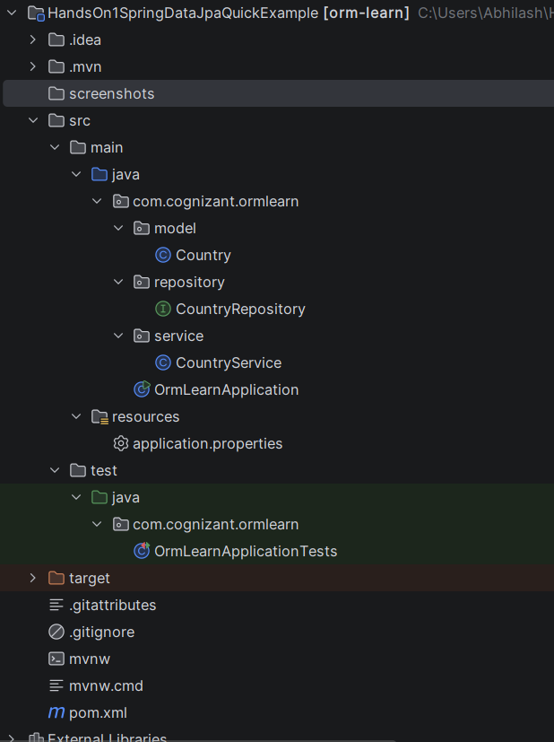

application.properties showing Hibernate configuration
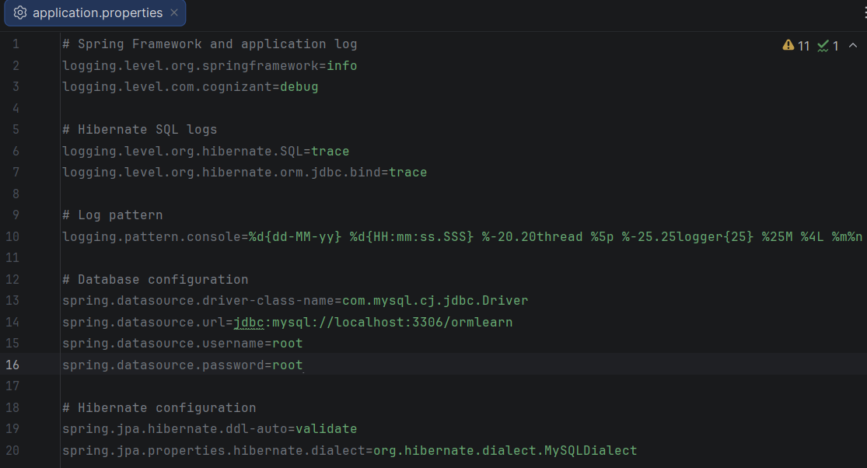

MySQL Workbench showing the populated country table (showed a few logs)
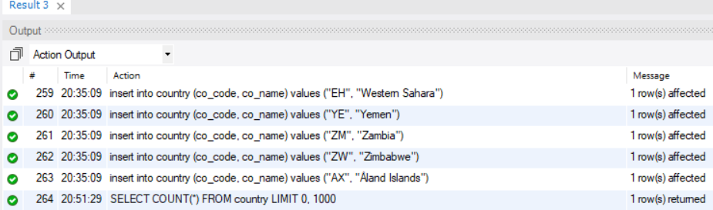

Result of SELECT COUNT(*) FROM country; showing the 249 records.
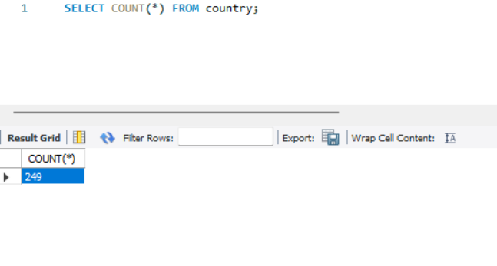

Result
The country table was successfully populated with all country records, and the Spring Boot application was configured to use the existing database schema.

Conclusion
The database was successfully configured and populated with country data. The application is now ready to implement CRUD operations using Spring Data JPA services.

